# Material Science – Schillfahrt

## Overview

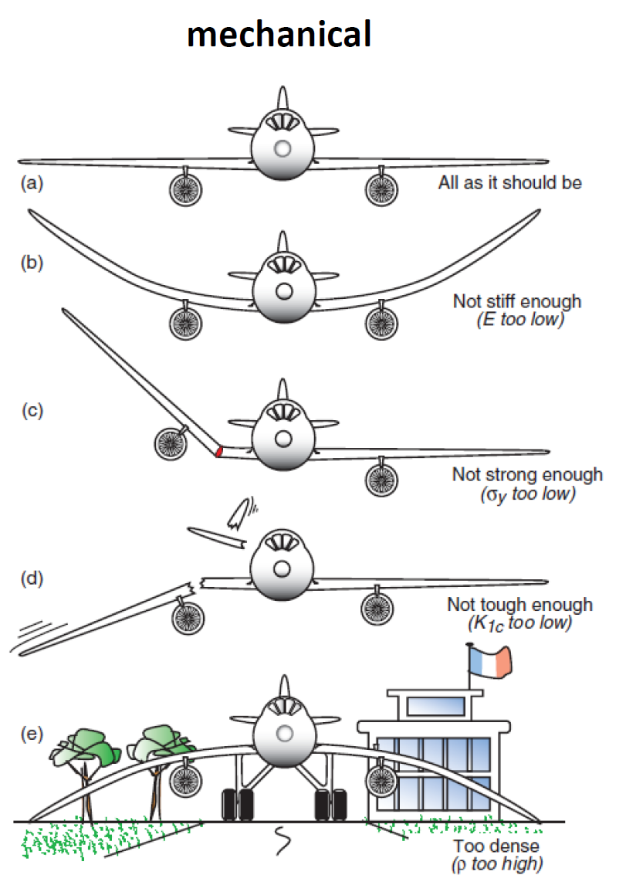 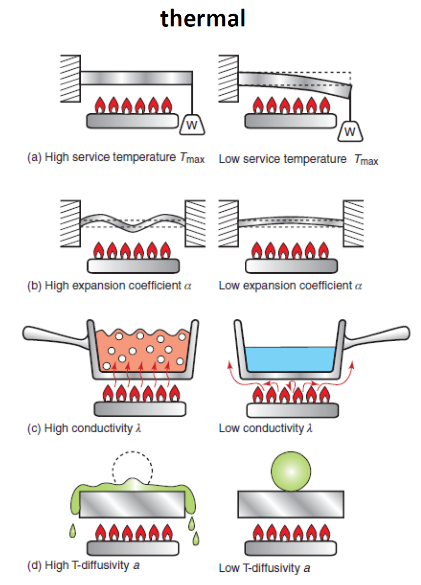

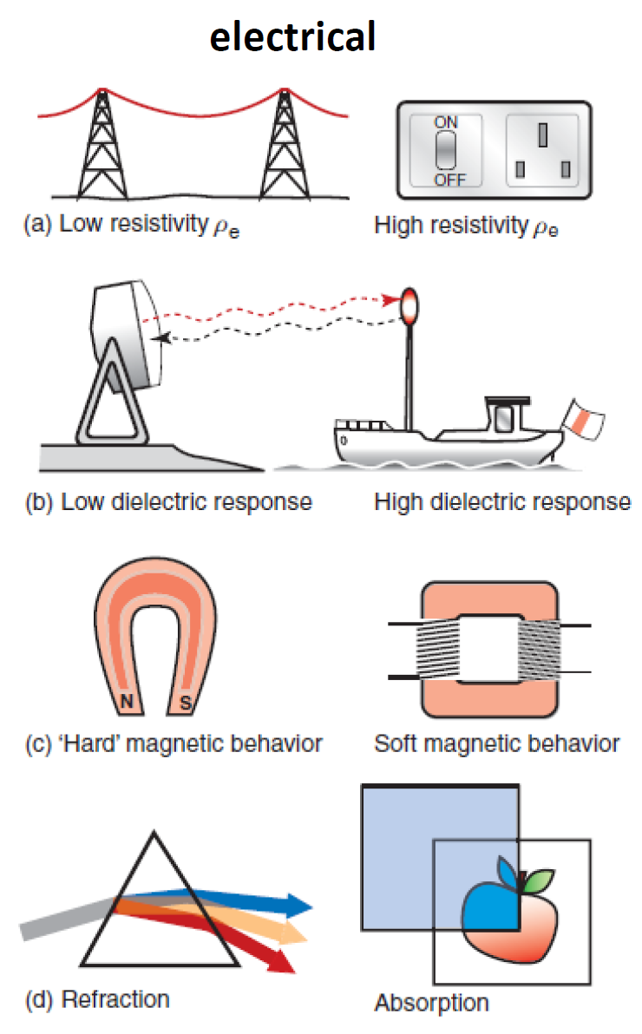 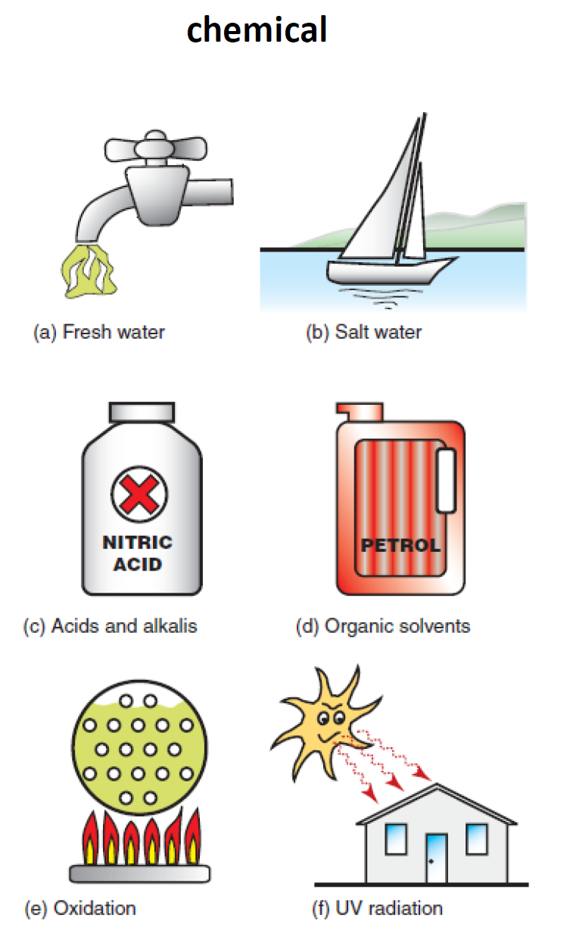





## Elastic Modulus

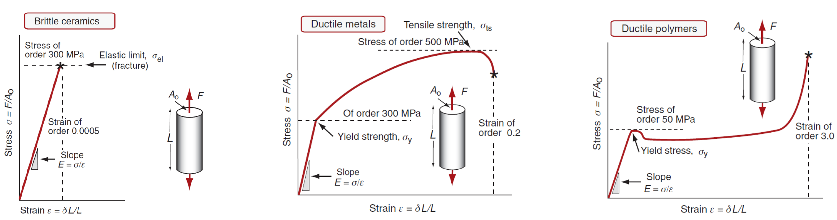

Difference between isotropic and anisotropic materials!

Poisson´s Ratio

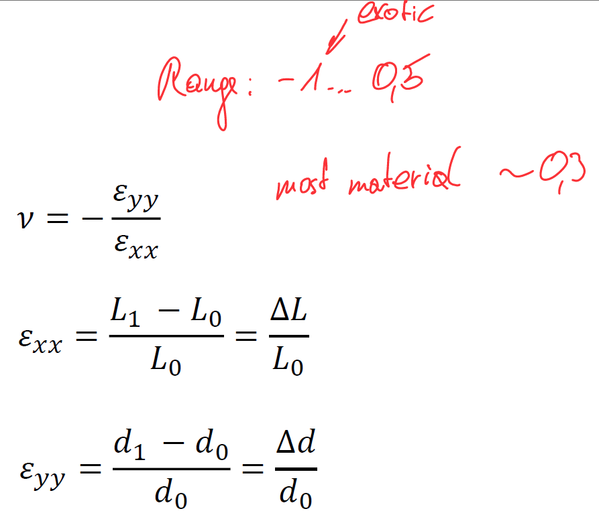

Stress Strain curve

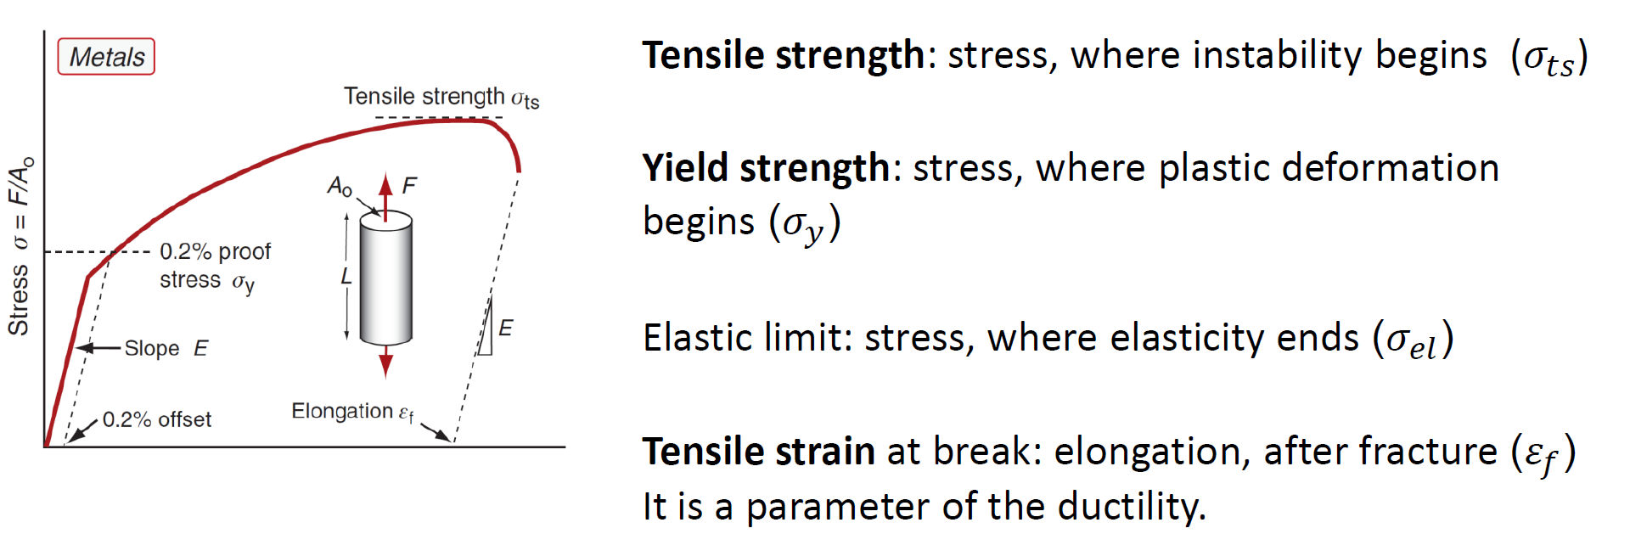

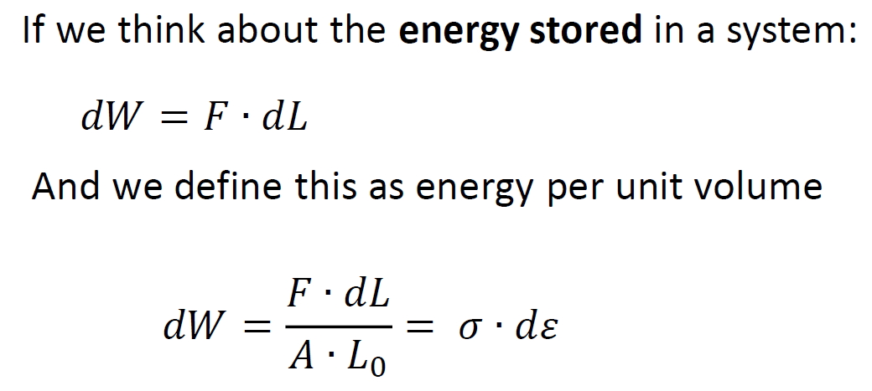 - crash box

Hardness

Vickers, Brinell, Rockwell, Shore, Knoop

Pressing different shapes with a defined force into a specimen.

Fracture Toughness

Ability to withstand a certain stress at crack zones

K1C

Fatigue behaviour

Wöhler Curve

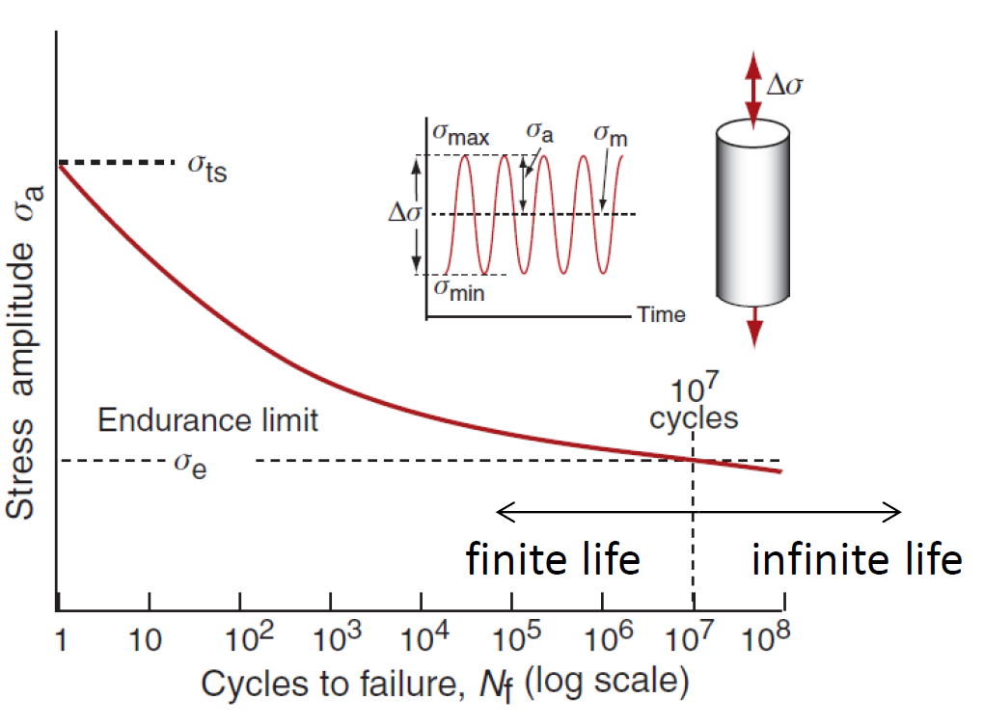

Damping capacity

Measure of internal friction, measures the degree to which a material dissipates vibrational energy

Wear rate

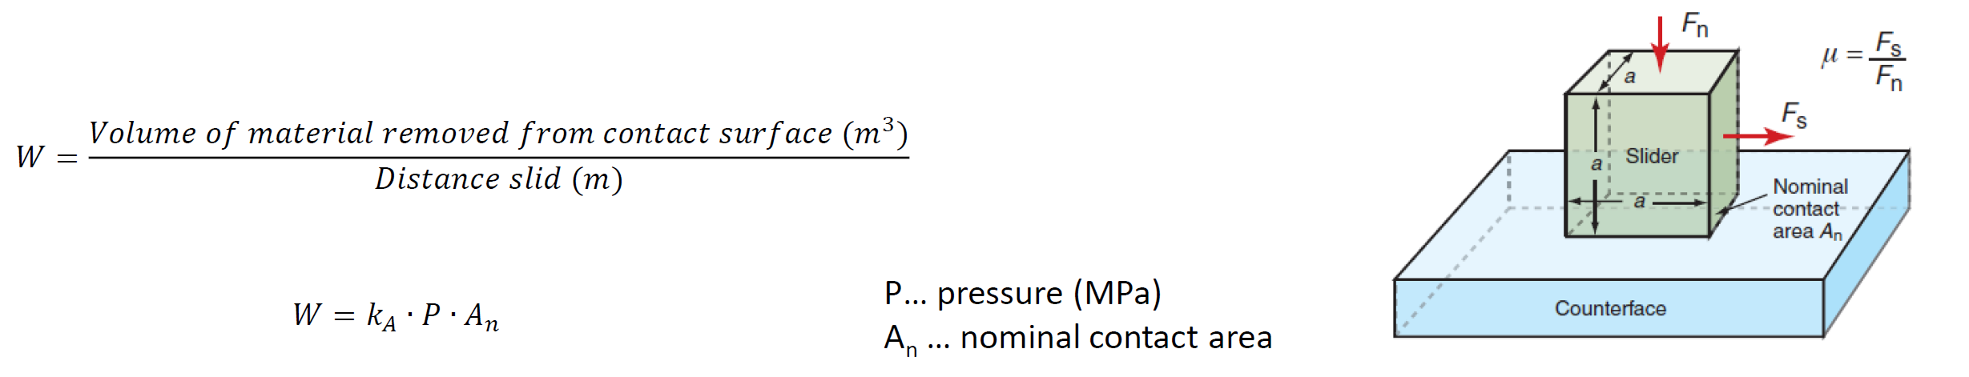

Creep deformation

A typical creep curve, which is measured by a creep tests (*constant loading, constant temperature*) is the same for metals, ceramics and polymers

Melting point and glass transition temperature

Maximum service temperature

 

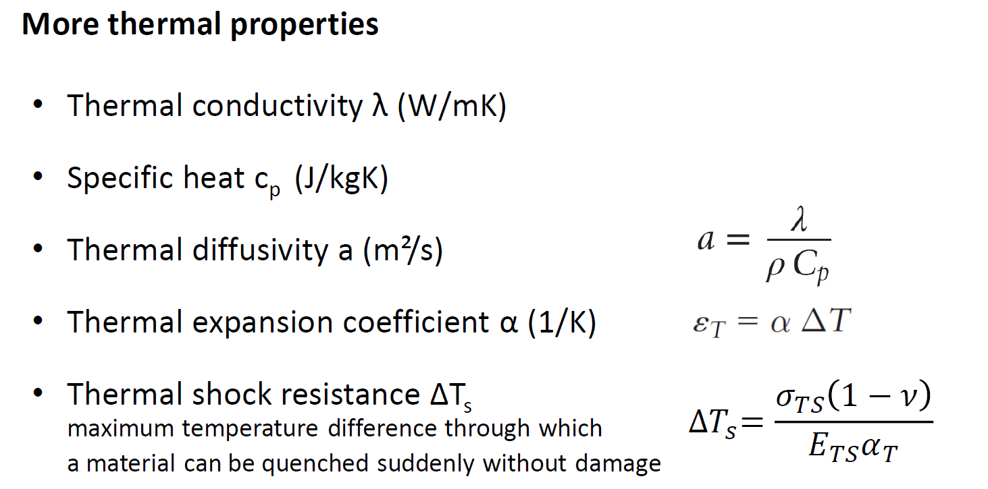

Electrical properties

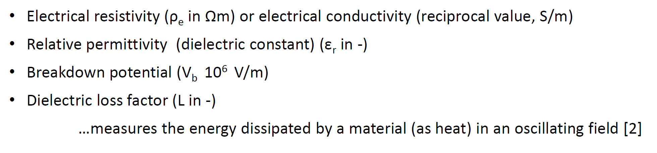

Refraction index

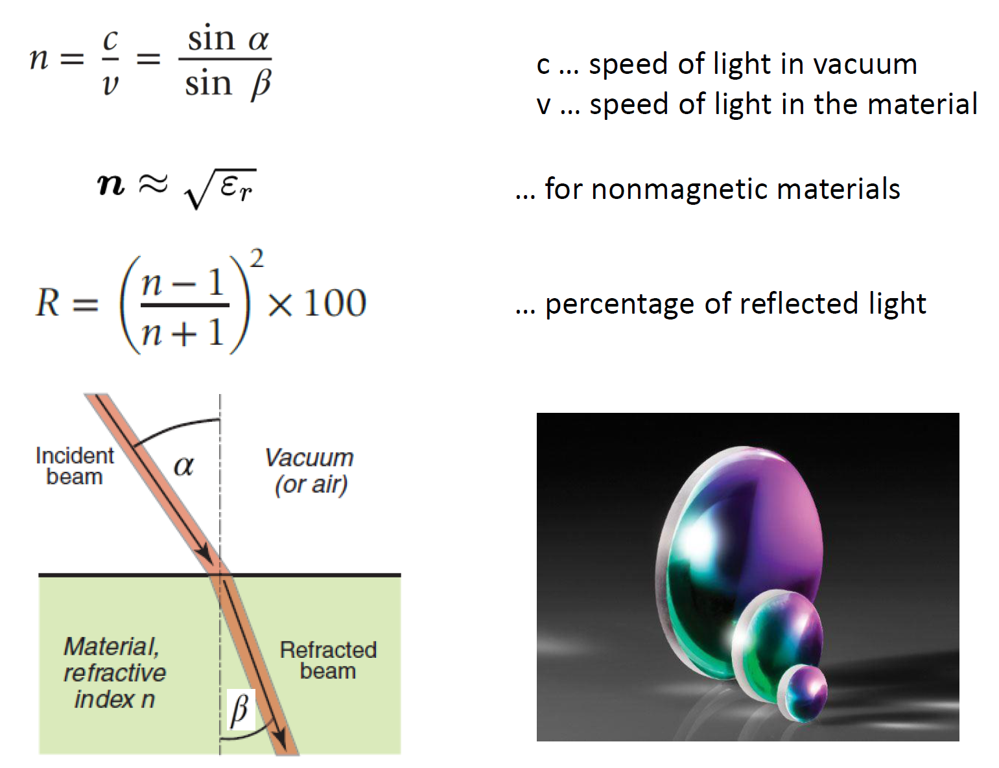

Eco properties

Embodied energy and undesired gas emissions (e.g. CO2 footprint ~equivalent)

In which life cycle phase???

# Ceramics

…are **inorganic**, **non-metallic** solids. Either **crystalline**, **amorphous** or **semi crystalline**

…formed by the application of heat (sometimes pressure)

…at least two elements, one of them non-metal or non-metallic solid

…strong ionic or covalent bondings

## Structures



1. Crystalline structure Quartz 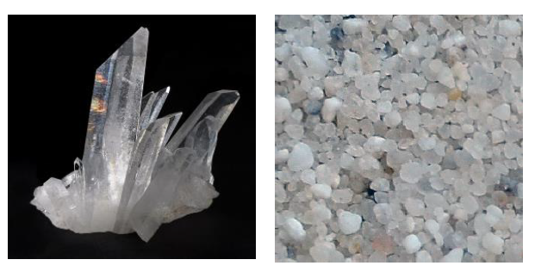
2. amorphous structure Quartz glass, fused quartz 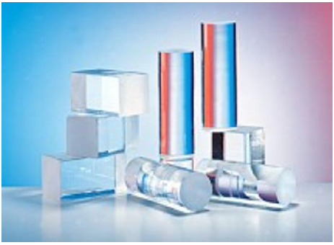

has no specific melting point – glas temperature point

1. amorphous structure with network modifier glass for bottles, windows 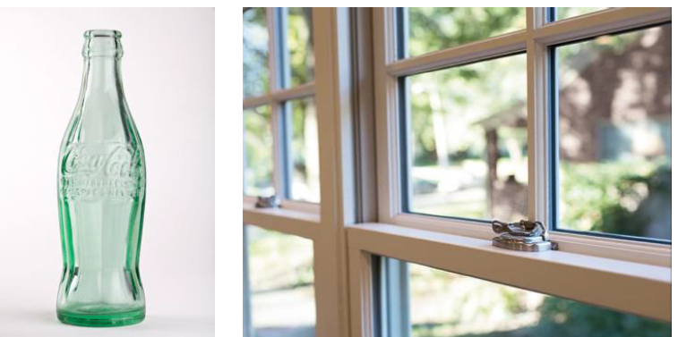

network modifier reduces manufacturing temperature

**Five classes of ceramics (Ashby)**

1. Glasses (based on silica SiO2)
2. Vitreous ceramics (traditional clay products)
3. High-performance ceramics (high wear resistance and temperature capability)
4. Cement and concrete (essential for civil engineering)
5. Rocks and minerals

**Classification of technical ceramics:**

1. Silicate ceramics (all based on SiO2)
2. Oxide ceramics (Aluminium & Magnesium Oxides)
3. Non-Oxide ceramics (carbide & nitride)

**Microstructures of ceramics**

Issues according to the manufacturing process – drawing with direction & heat elongation



**Advantages for technical ceramics**

* High hardness
* Excellent wear resistance
* High temperature stability

**Disadvantages for technical ceramics**

* Brittle material behaviour
* Low value of elongation at rupture
* Difficult to fabricate

Ceramics are often used at high maximum service temperatures



For coatings the thermal expansion has to be similar to the base material – otherwise cracks/damage

**Piezoelectric effect**

* Direct effect – voltage via compressive stress
* Inverse effect – small movement via voltage

Applications: force sensor, ultrasonic actuators, electrical elements (medical ultrasonic device)

**Hardness**

Hardest of solids without further treatments (like metals) – because of covalent bondings

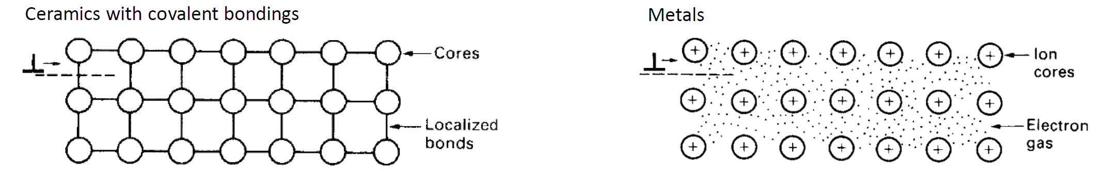

**Very poor fracture toughness**

brittleness

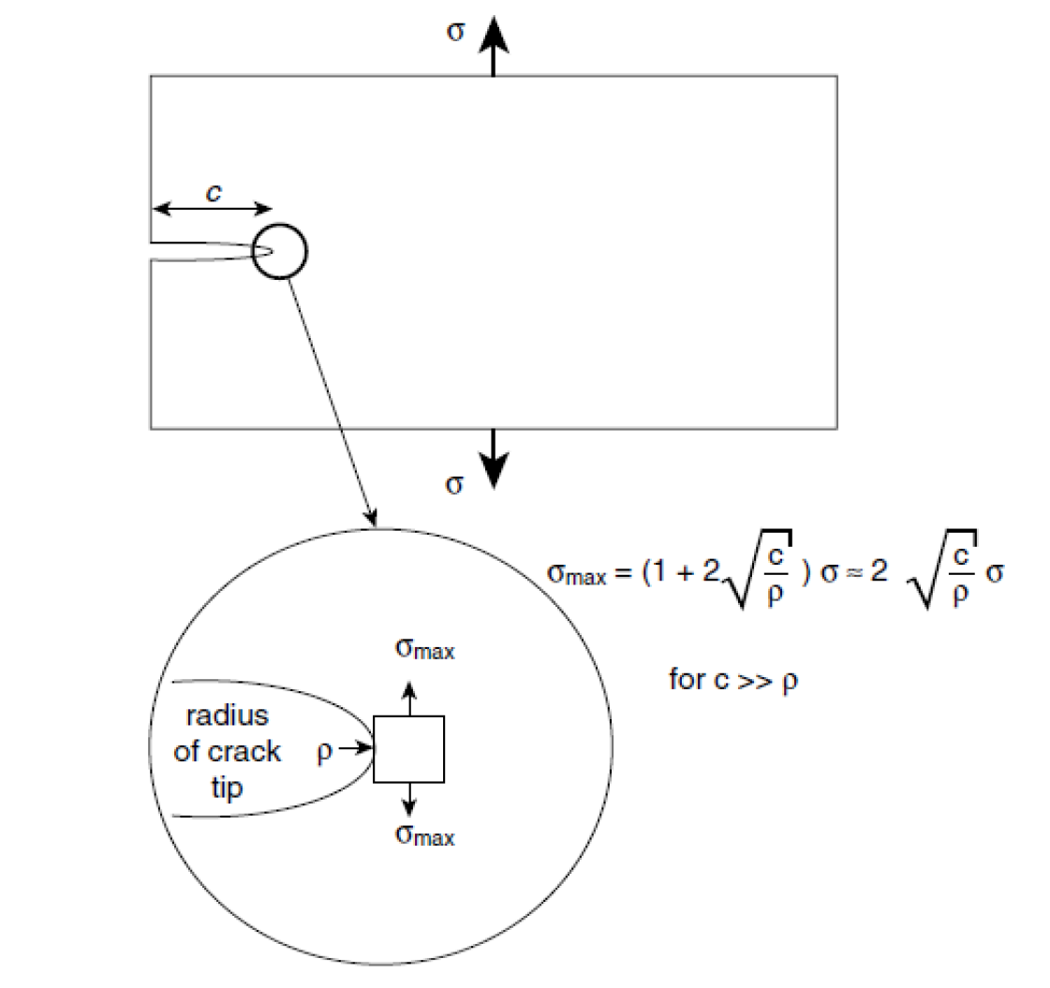 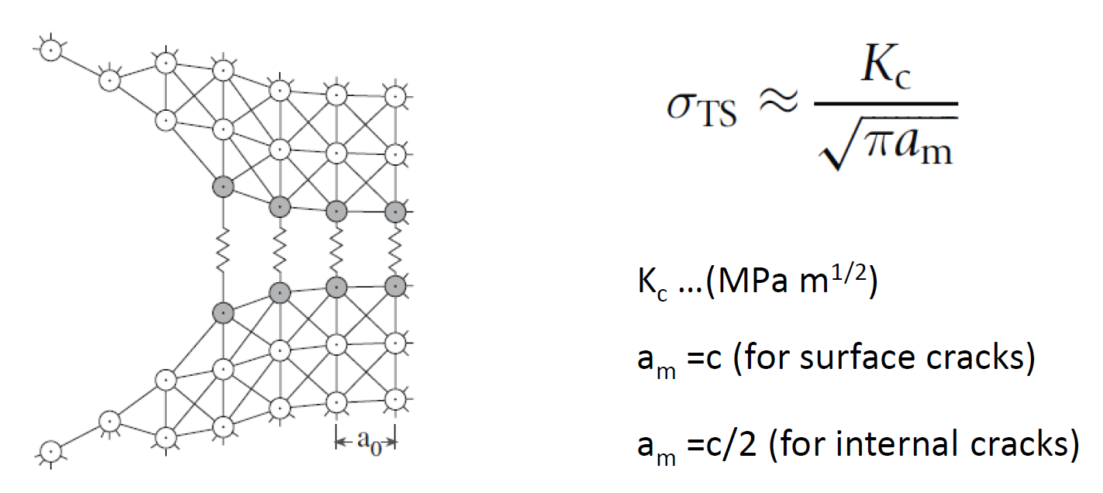

**Crack propagation**

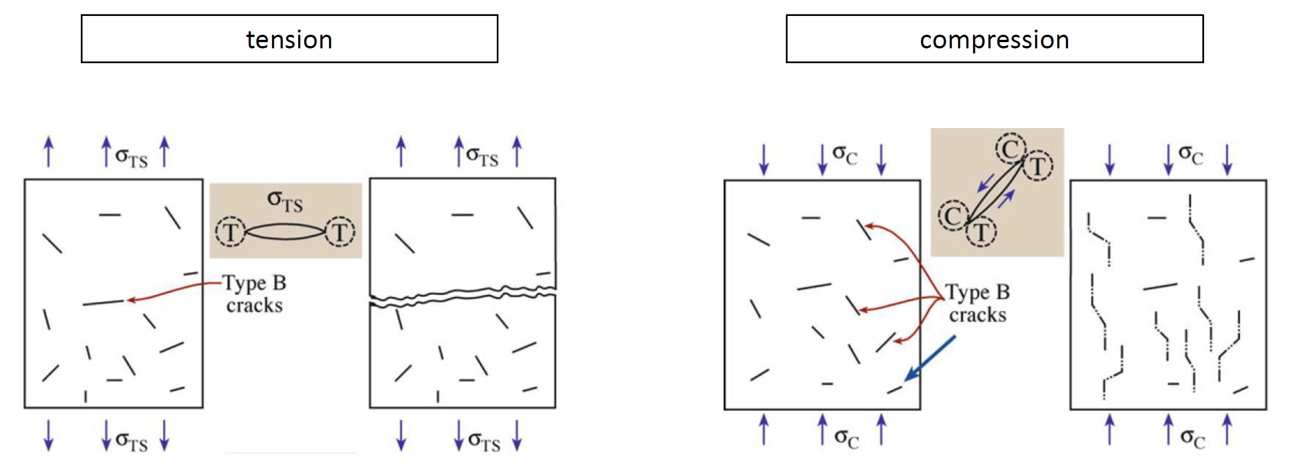

Cracks open under tension and close under compression

**Weakest link fracture theory**

Weakest link gives up first – therefore just fibre (glass fibre, carbon fibre)

CF ø7µm

GF ø15µm

Human hair ø50µm

**Weibull distortion**



The higher the Weibull modulus, the lower is the variability of strength

e.g ceramics m=5-20; steel m=~100

compared to the max tensile strength (no yield strength!)

**Tests**

Just bending – clamping could damage

Four-point bending – weakest link theory...

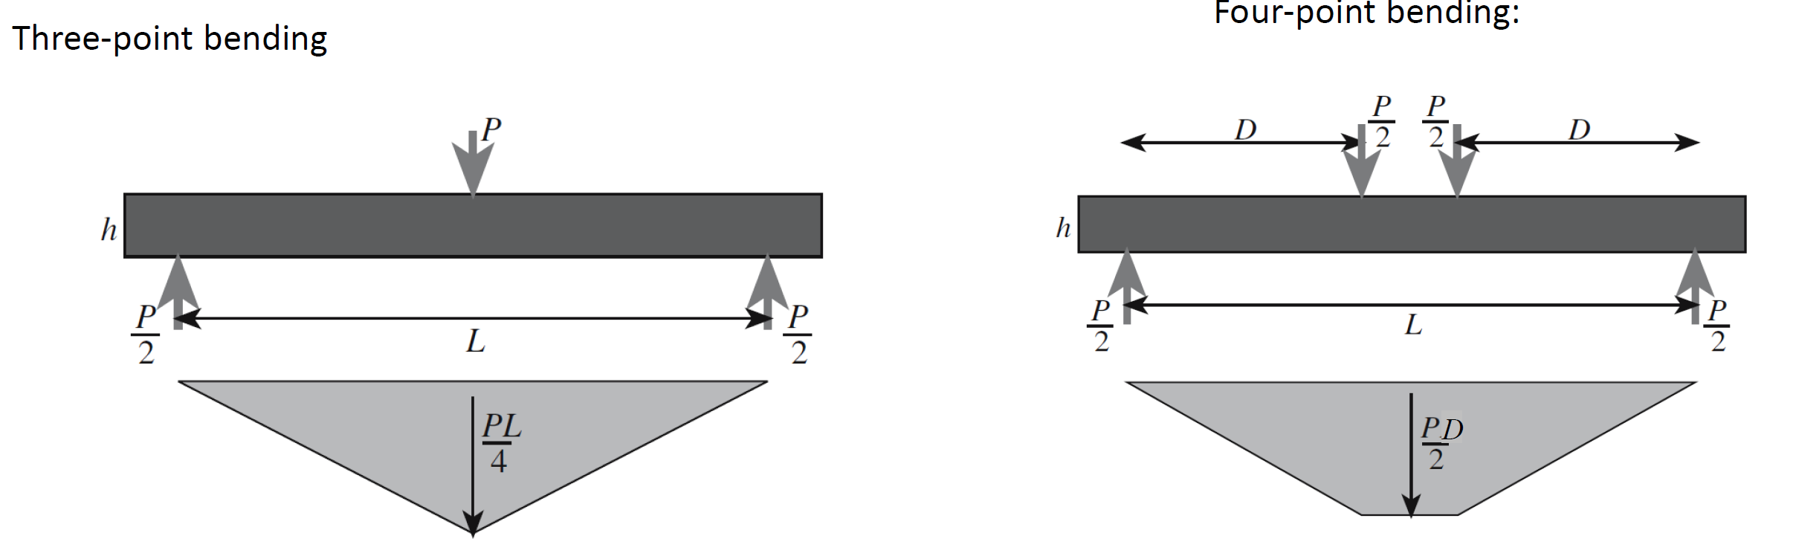

**Ceramics – design guidelines**

Most important – avoid stress concentration

* Leaps (jumps) of the cross-section should be avoided
* Sharp edges should be avoided
* Preferably compressive load
* High edge loading should be avoided
* Differences of the coefficient of thermal expansion must be considered (ceramic coatings...)
* ceramics tend to creep at high temperatures (>1/3 TM)
* Ceramics sometimes show a timed dependency of strength: slow crack growth
* Thermal shock resistance has to be considered (temperature differences)

**Sintering**

Process with high temperatures and pressure (T>0,5*TM)

* Fine particles sinter much faster than coarse ones because the surface area (and thus the driving force) is higher and the diffusion distance are smaller.
* The rate of sintering varies with temperature in exactly the same way as the diffusion coefficient. Higher temperatures accelerate the sintering process.

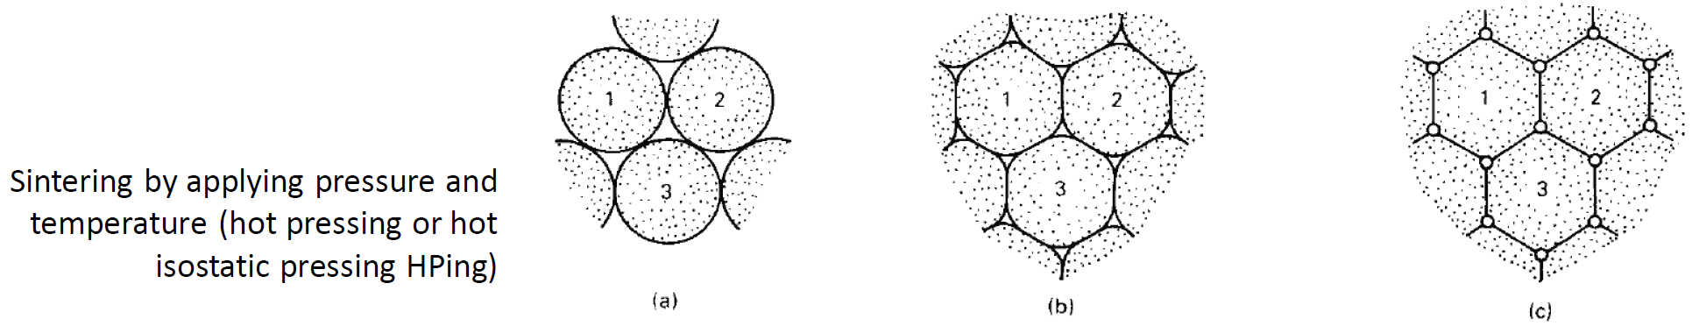

# Polymers

Types of polymers:

* Standard plastics
* Technical design plastics
* High temperature plastics

Key to mass production... (most of the parts in the automotive sector)

Structure:

Macromolecules with strong covalent bonds

Long chains – like spaghetti

Thermomechanical properties defined by secondary binding forces (intermolecular bonds)

Dispersion forces lead to crystalline structures

Hydrogen bonds:

...are very strong bondings – PA6 has often those bondings -> reason for high usage

Steric hindering:

Flexibility because bonds have ability to rotate



Want to get at energy minimum -> reason for deformation...

Semi crystalline polymers – get in regular older

**Classes of Plastics:**

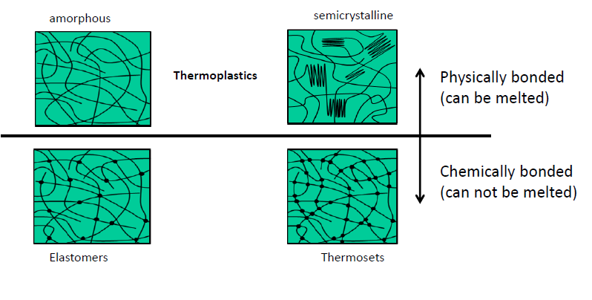

Elastomers:

...almost linear polymers – occasional cross -links (2nd bonds already melted at room temperature)

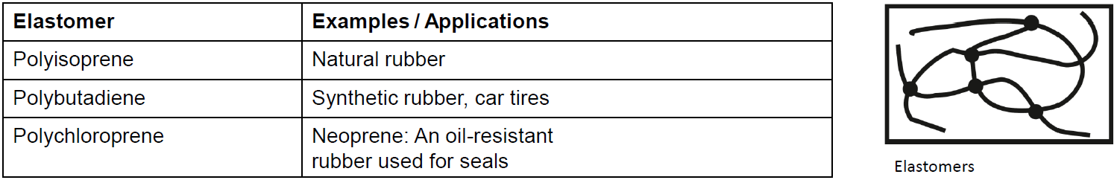

Thermosets:

...are made by mixing two components which react and harden (1 resin & 1 hardener) – heavy cross-linked – cant be hot-worked

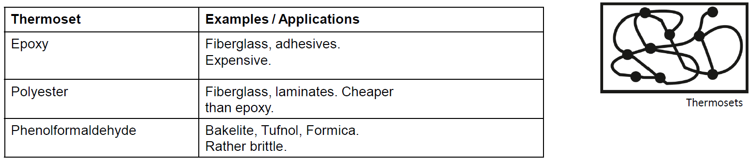

**4 Groups (important slide!)**

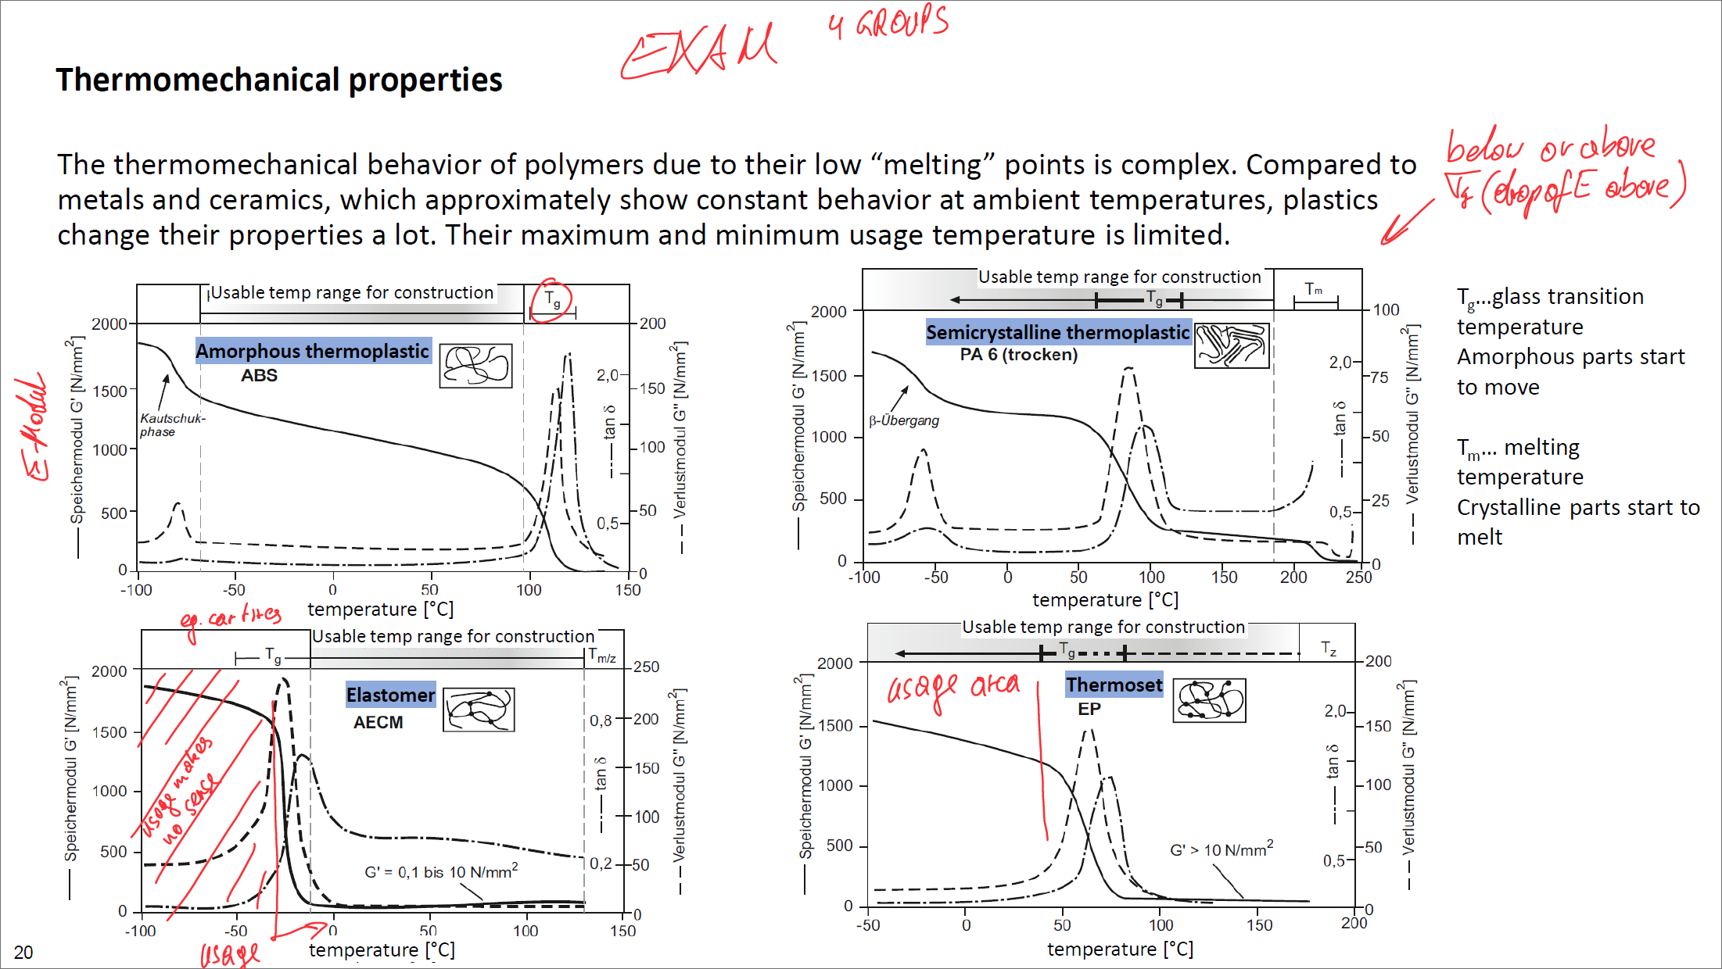

Explanation:

Amorphous thermoplastics - no melting - decomposition

Semicrystalline thermoplastics – glass transition point and melting point due to cystanline structure which gets “solved”

Elastomers – no melting point due to strong cross-link bondings – just decomposing

Thermosets – no melting point due to strong cross-link bondings – just decomposing

**Discussion of the E-Module according to the temperature**

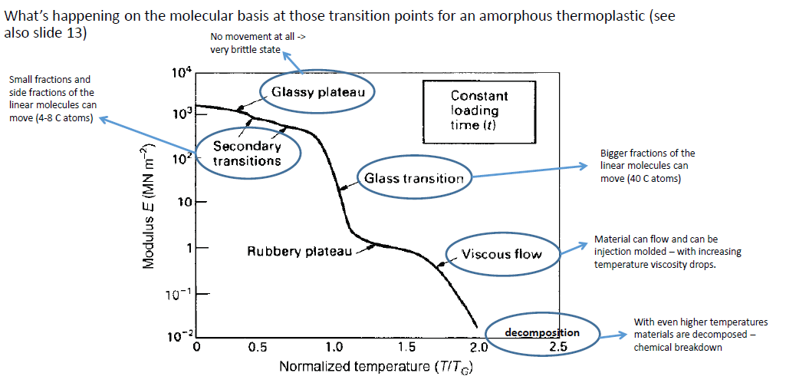

Polymers are not only dependent on **temperature** but also **time** dependent

Because of their long chains (molecules) – change over time

Thermomechanical properties

Mosty secant modulus

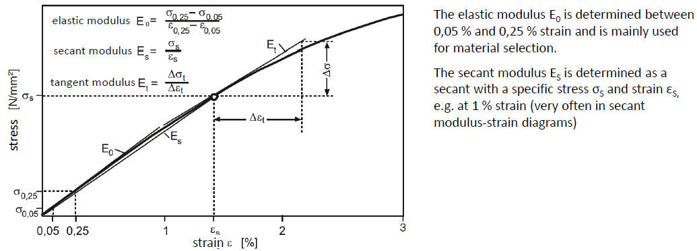

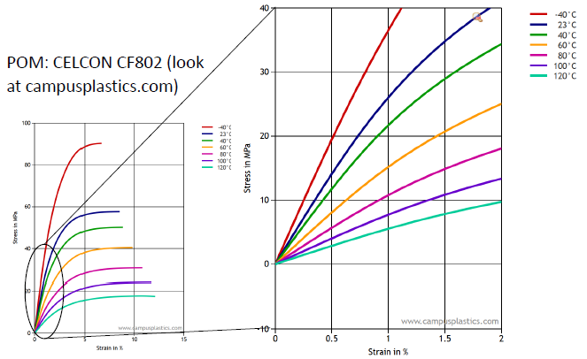

Creeping of polymers

Polymers tend to creep (some even at room temperature)

Parts of deformation:

* Elastic part (back to original shape)



* Viscoelastic part (after a certain time period back to original shape) 
* Viscous part (permanent deformation)



* Isochronous stress-strain diagram for polymers

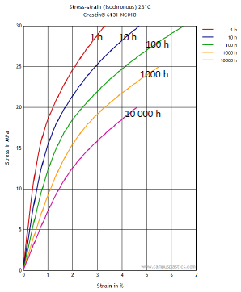

Thermomechanical behaviour:

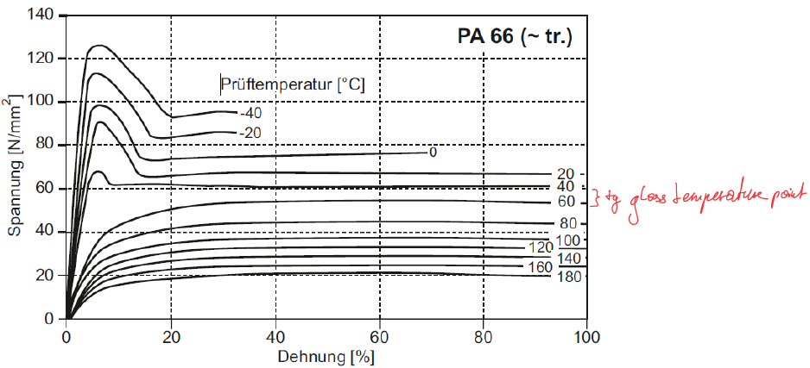

Time dependency at fracture:

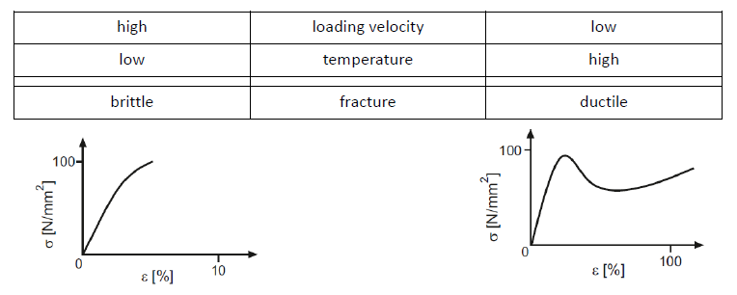

Some materials are stronger when loads are fast applied.

Fracture toughness:

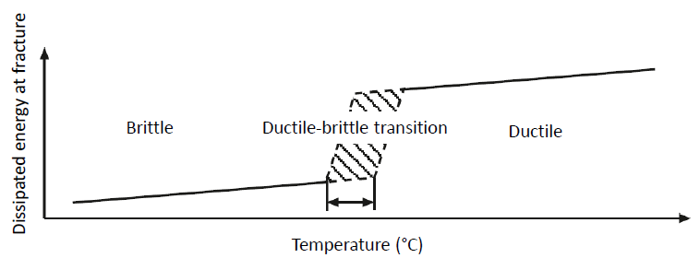

Stiffness, max Yield-Strength and Fracture Toughness -> depend on temperature

* **Tmin and Tmax of a system have to be known!**

Water absorption

...can make polymers more ductile (especially with polar side groups e.g. PA6)

**Types of fracture:**

* Brittle fracture no movement of polymer chains possible

below 0,75 TG -> low toughless materials – avoid stress concentration

* Cold drawing (Kaltziehen) mainly in partially crystalline polymers

Normally not considered – phase after yield to fracture

* Crazing (Rissbildung) in polymers with higher TG -> amorphous polymers

No reduction in the cross-sectional area -> increase in volume

* Shear banding (Scherbildung) can also occur in tension (mixture with crazing)

**Design Guidelines for Polymers**

* Flexible structures
  + Low modulus (elastomers)
  + Flexible structural design (thin walled)
  + Direction of force (torsion or bending)
* Stiff structures
  + Design is more important than the material stiffness  
    
  + Always consider incorporation of ribs, stiffener beads or joining of two half-shells
  + Closed, hollow profiles show best stiffness to weight ratio
* Thermal expansion
  + Consideration of higher tolerances
  + Combination with stiffer materials (outsert technique)
* Construction of joints
  + Use of different materials which do not mix e.g. POM and PA

# Hybrids

At least two combined material families



Reason: => improve/strengthen material properties and cancel out weaknesses of materials

Properties:

* Strength
* Stiffness
* Impact
* Density
* Thermal and electrical properties

Different approaches of mixture of properties:



Reason why C-Fiber or G-Fiber Hybrids are often used in high performance sports:



Physical properties are highly dependent on the direction of the fibres:

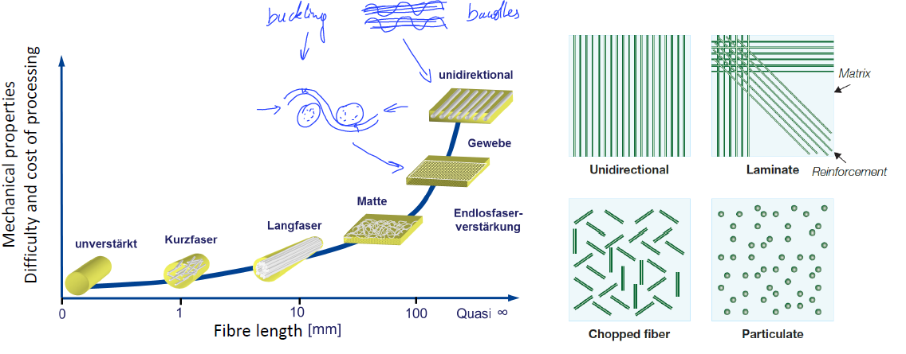

Fibers have to be very thin -> weakest link theory ....

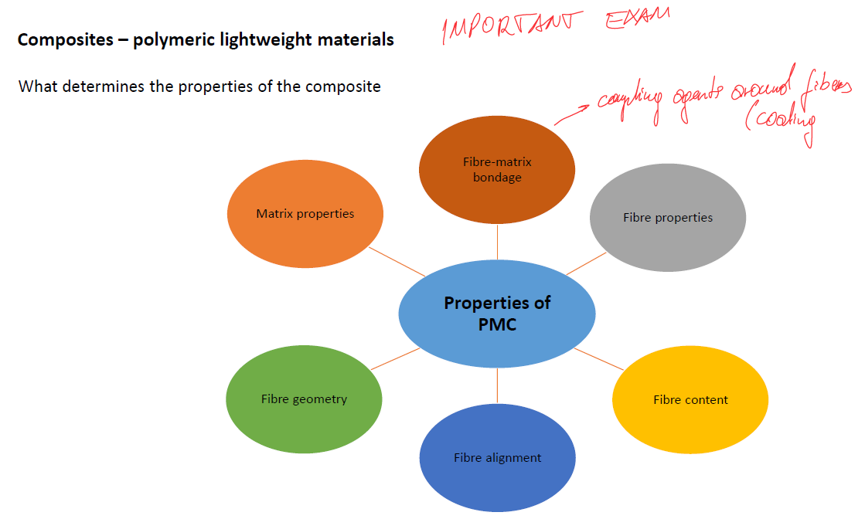

Composites could be used with different matrix systems

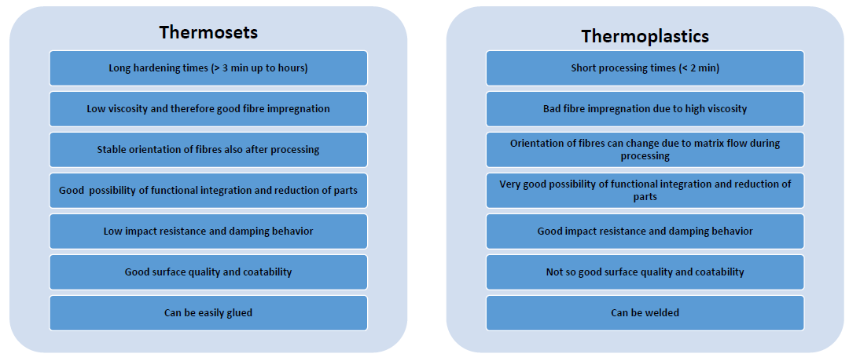

Main Fibre systems:

* Glass fibre
  + Cheap but heavy
* Carbon fibre
  + Light, very high elastic moduli and strengths, shows brittle failure
* Aramid fibre (Kevlar)
  + Light, good impact behaviour (damping), pure compression behaviour

Other Fibre systems:

* Polymer fibres (polyethylene, polypropylene)
* Natural fibres (flax, hemp, sisal)

Influence of the fibre content in the stress strain diagram

